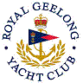 | Royal Geelong Yacht Club Inc.  Est 1859
Trophy Deed of Gift.

Trophy: | Six (6) Trophies
Presented by: | Frank & Addy Buecek
Date: | 1974
From: | International Cadet Dinghy World Titles
Remarks / Revisions | Portugal

